CIS 353

Week 5 Notes

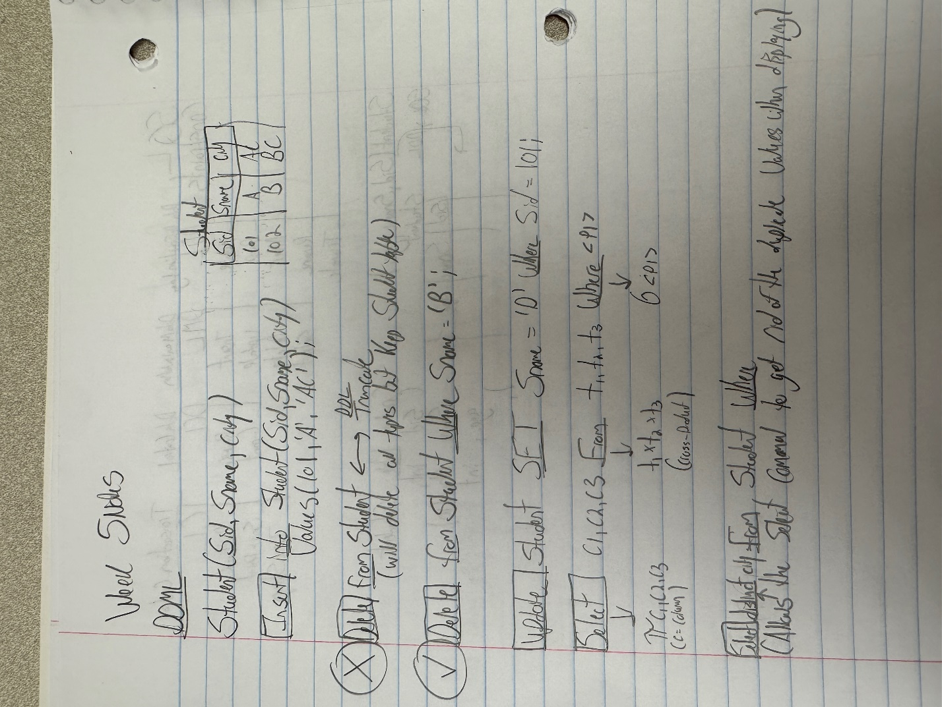

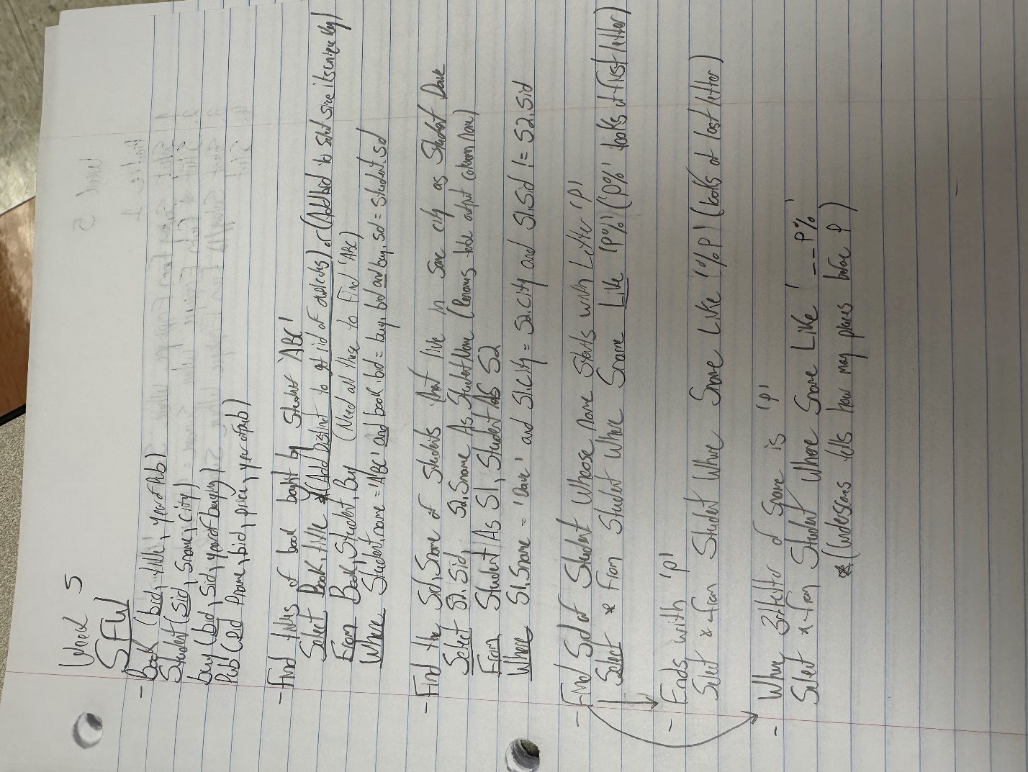

**Nested Query –**

Select E1.empname from employee E1, employee E2 where E2.empname = ‘Adam’ AND E2.empid = E1.empid AND

**Is the same as this:**

Select empname form employee where empheadid = (select empid from employee where empname = ‘Adam’)

Aggregated Functions –

Table name emp columns, empid, name, salary

* Max
  + Select max (salary) from emp
* Min
  + Select min (salary) from emp
* Sum
  + Select sum (salary) from emp
    - Adds all the real values and give results
* Count
  + Select count (distinct salary) from emp
    - Will count no null or duplicate values
  + Select count (salary) from emp
    - Will count all tuples but null
  + Select count (*) from emp
    - Count the total number of tuples in the table.
* AVG
  + Select AVG (salary) from emp
    - Gives you the average of all real numbers

Order by limit

Select * from emp order by salary

* This sorts the table by sorting the salary by least the greatest number
* Add desc at end to reverse order

Select * from emp order by salary limit 1;

* Find the first (limit number) tuples of the table
* So fist tuple in this example